**Market Basket Analysis-Phase_4**

Market basket insights involve examining the purchasing patterns of customers to identify relationships between different products or items they buy together. This analysis is particularly useful for businesses, especially in the retail and e-commerce industries, as it can help improve product recommendations, optimize store layouts, and plan marketing strategies. Here's how AI is used for market basket insights:

1. Data Collection: AI systems collect transaction data, such as point-of-sale data, e-commerce purchase history, or customer receipts. This data typically includes information about the items purchased and the transactions' timestamps.
2. Data Preprocessing: Raw transaction data may contain noise or inconsistencies. AI is used to clean and preprocess the data, ensuring that it is ready for analysis.
3. Association Rule Mining: AI algorithms, such as Apriori and FP-growth, are used to identify associations or relationships between items in customers' baskets. These algorithms find item sets that tend to appear together in transactions more frequently than expected by chance.
4. Support, Confidence, and Lift: AI calculates metrics like support, confidence, and lift for each association rule. These metrics help determine the significance and strength of the relationships between items in the market basket analysis.
   * Support: Measures the frequency of an itemset in the data.
   * Confidence: Measures how often the rule is true.
   * Lift: Measures how much more likely items are bought together than if they were bought independently.
5. Rule Generation: AI generates a set of association rules based on the chosen support, confidence, and lift thresholds. These rules provide insights into which items are frequently purchased together.
6. Visualization: AI can be used to create visualizations and reports to help businesses interpret the results of market basket analysis. Visualizations may include network diagrams, heatmaps, and item co-occurrence matrices.
7. Recommendations: AI-powered recommendation systems use the generated association rules to provide personalized product recommendations to customers. These recommendations can be displayed on e-commerce websites or in-store to encourage cross-selling and upselling.
8. Inventory and Supply Chain Management: Market basket insights can also be used to optimize inventory management and supply chain logistics. Businesses can adjust their stock levels and reorder strategies based on the items that tend to be purchased together.
9. Marketing Campaigns: Businesses can use market basket insights to design targeted marketing campaigns, including bundling related products or offering discounts on items frequently purchased together.
10. Store Layout Optimization: AI can help retailers optimize the layout of physical stores based on the insights from market basket analysis. Placing related items near each other can increase sales.

Flow Diagram:

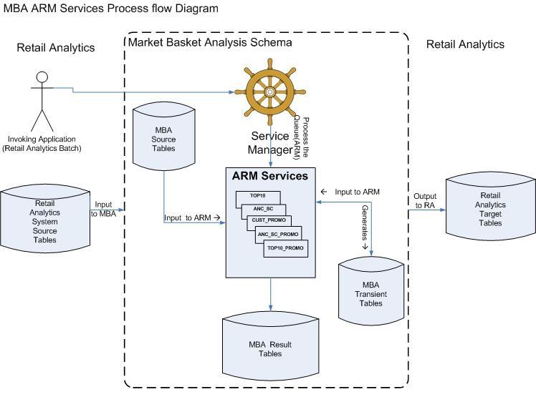

**Problem Statement:**

For demonstration, we are going to perform Market Basket Analysis on retail data using the Apriori Algorithm. The dataset provided needs to be pre-processed beforehand to make it usable.

The dataset has 8 features as given below:

* *InvoiceNo* – Invoice number
* *StockCode* – Stock code of the item
* *Description* – Description of item
* *Quantity* – Quantity of item
* *InvoiceDate* – Data of invoice generation
* *UnitPrice* – Price of item per unit
* *CustomerID* – ID of the customer
* *Country* – Country of residence

**Tasks to be performed:**

1. Importing required libraries
2. Loading the data
3. Cleaning the data
4. Creating basket
5. Encoding
6. Generating frequent itemsets
7. Generating association rules
8. Filtering rules with high Confidence and Lift

Association Rule Mining through the Apriori algorithm is a widely known technique in machine learning to perform Market Basket Analysis. This analyzing process is used to discover the association between products in a manner that will be helpful for retailers or marketers in developing useful marketing strategies and business plans.